Synthetic Turf Heat Issues

Multiple studies have looked at temperature comparisons between natural grass and synthetic turf.⁽¹⁻⁶⁾
Temperatures have been recorded as high at 200 and 202ºF.

The surface temperature of synthetic turf, regardless of brand or infill, is always hotter than natural grass, air temperature, concrete, asphalt and bare soil.^{(4).} Temperature readings on synthetic turf can be 87ºF on the surface and 70ºF higher than air temperatures. It is NOT ADEQUATE to rely on weather forecasts to determine when to call of a game due to high synthetic turf temperature, but you can be assured that in our climate, this will involve an ever increasing number of days. Failure to do so will result in the very high likelihood of lawsuits in the event of injury or death!

Children are closer to the higher heat on the surface and air than adults. They are less able to adapt to higher temperatures and therefore more prone to dehydration, heat stroke and other related health issues.

Turf burns provide open access for bacteria. Of particular concern is Methicillin Resistant Staph Aureus, MSRA, which has been found in 70% of synthetic turf fields. MRSA infections are not readily discernible and require rapid IV antibiotic intervention. They can rapidly progress to abscess and even death.

The predicted increased amount of play time provided in the staff report is UNREALISTIC given our increasing temperatures in Southern California and neither the erroneously predicted increase in play time NOR the exorbitant expense of tax payer money warrants exposing humans or the environment to the multitude of toxins and carcinogens the staff report has chosen to ignore by selectively choosing to quote Dan Hogan & Associates, who has a special interest in promoting sales of synthetic turf AND by selectively quoting 2 special interest backed studies while ignoring the abundance of scientific reports available.

SYNTHETIC TURF CREATES URBAN HEAT ISLANDS, OFF GASSES CARBON, LEACHES TOXINS AND CARCINOGENS INTO THE ENVIRONMENT AND IS NOT ONLY IN CONFLICT WITH HUMAN AND ENVIRONMENTAL HEALTH, BUT THE CITY’S OWN CLIMATE ACTION GOALS.

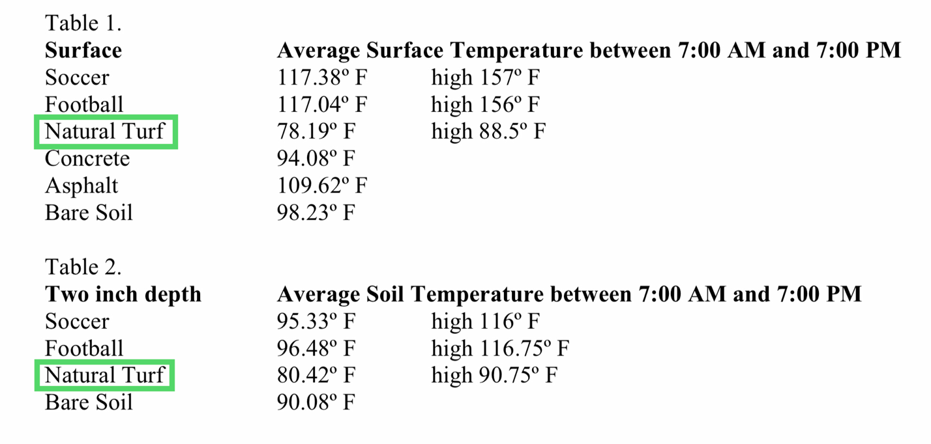

Williams, F, Pulley, G (2002). Synthetic Surface Heat Studies. Brigham Young University (Provo, UT).
https://aces.nmsu.edu/programs/turf/documents/brigham-young-study.pdf

Myrick, S (2019). Synthetic Sports Fields and the Heat Island Effect. National Recreation and Park Association (Ashburn, VA); online publication.
https://www.nrpa.org/parks-recreation-magazine/2019/may/synthetic-sports-fields-and-the-heat-island-effect/

Yaghoobian, N, Kleissel, J, Krayenhoff, ES (2009). Modeling the Thermal Effects of Artiﬁcial Turf on the Urban Environment. Journal of Applied Meteorology and Climatology (Boston, MA ); vol 49, pp 332-345.
https://www.academia.edu/12123877/Modeling_the_thermal_effects_of_artificial_turf_on_the_urban_environment

John Abraham (2019) Heat risks associated with synthetic athletic fields, International Journal of Hyperthermia, 36:1, 515-516, DOI: 10.1080/02656736.2019.1605096
https://www.tandfonline.com/doi/full/10.1080/02656736.2019.1605096

Pryor, JL et al (2017). The Heat Strain of Various Athletic Surfaces: A Comparison Between Observed and Modeled Wet-Bulb Globe Temperatures. Journal of Athletic Training ( ); 52(11), 1056-1064.
https://www.natajournals.org/doi/full/10.4085/1062-6050-52.11.15

